Synoptic Meteorology I

**Lab 10: Kinematics**

Wednesday November 30th, 2022

Name:­­­­­­­ ________________________________________________________________

Due: December 7th, 2022, at 2:30pm

**Objectives**:

* Identify basic kinematic properties of the horizontal wind field.
* Explain how horizontal shear and flow curvature contribute to relative vorticity.
* Explain how changes in wind speed and wind direction contribute to divergence.
* Gain an introductory understanding of the relationship between horizontal vorticity advection and vertical motion.

**Things to know:**

Feel free to use the Internet and collaborate with your colleagues when answering these questions. For Part II, III, and IV, the requested plots must be obtained using the Jupyter Notebooks on our JupyterHub before you can complete the questions. Be sure to review the concepts covered in these tutorials rather than just complete the tasks they require as you may be asked to use these concepts in a future lab.

**Part I: Basic Wind Kinematics (30 pts)**

For questions 1-8, describe the kinematic process represented by the image. (3.75 pts each)



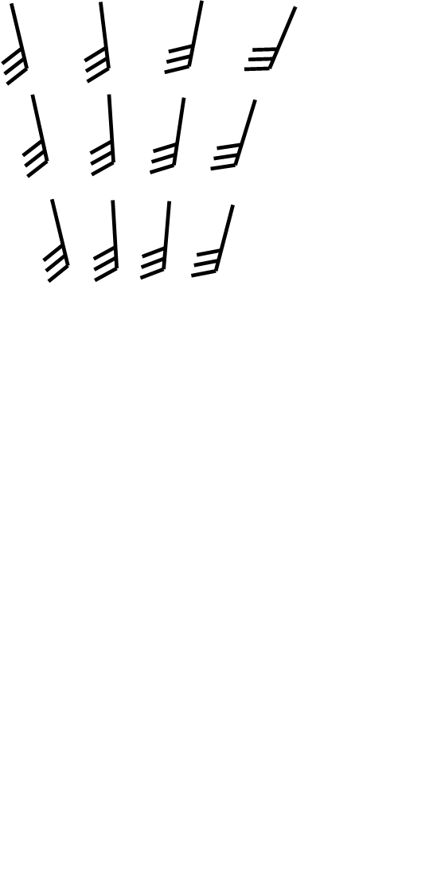

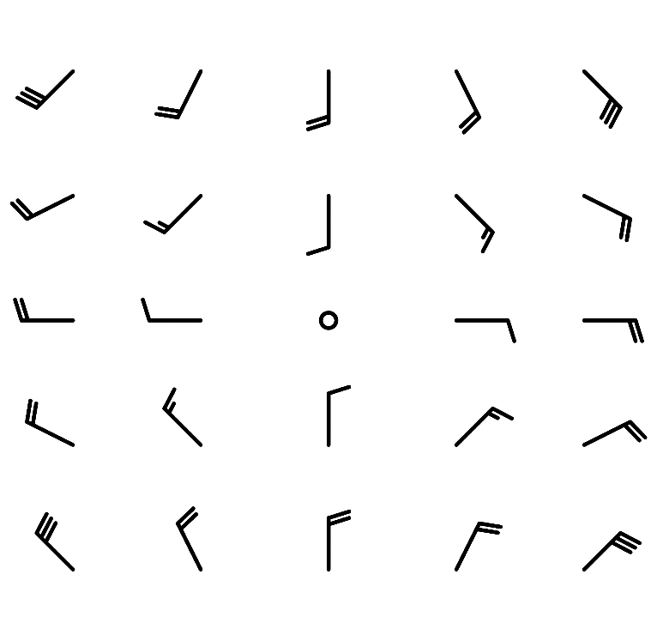

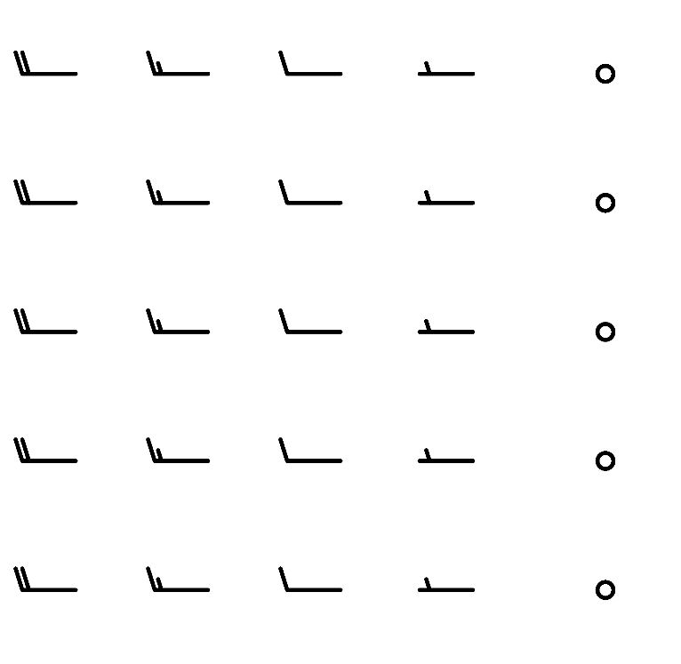





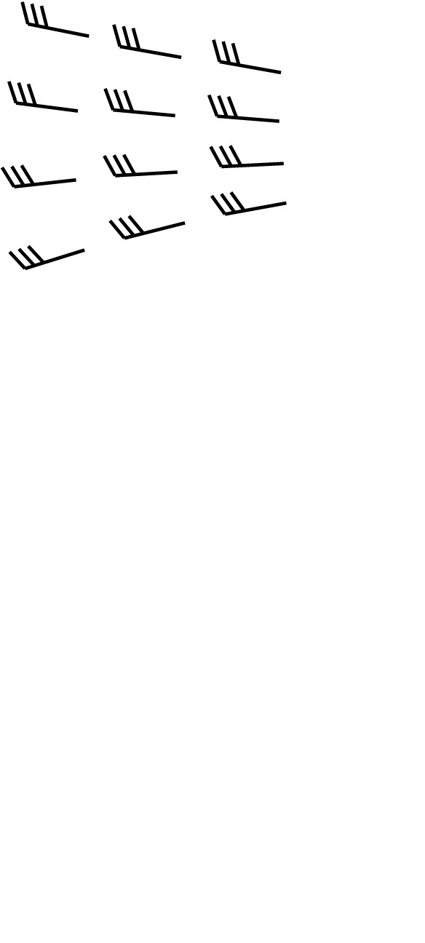

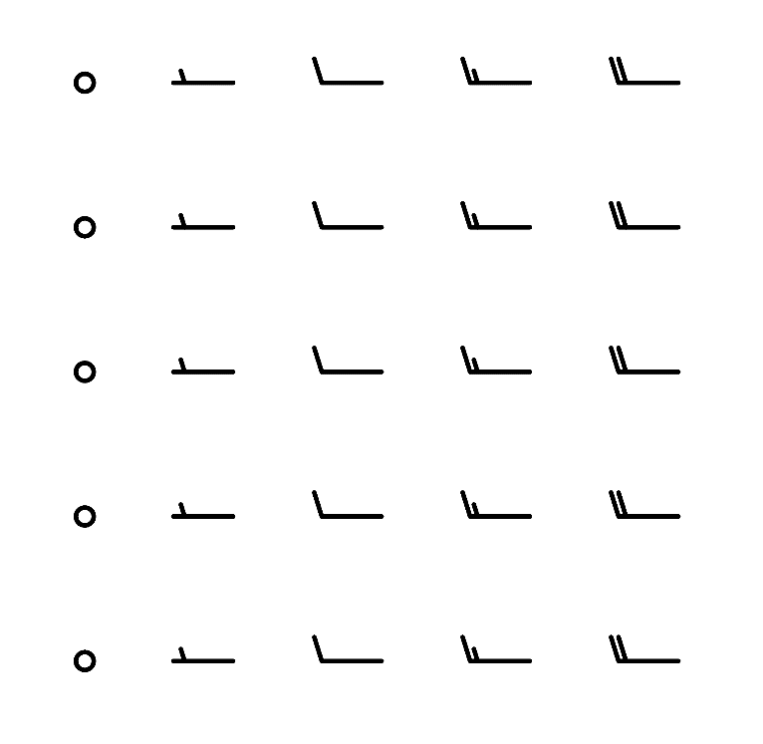

**Part II: Contributions to Vorticity (35 pts)**

Answer the following questions using the equation for relative vorticity in natural coordinates, $ζ= \frac{V}{R}- \frac{∂V}{∂n}$

1. Complete Parts I and II of the Jupyter Notebook exercises. (20 pts)
2. Using your 500 hPa map for October 12th, 2022 at 1200 UTC:
   1. What is the primary contributor to relative vorticity (positive or negative) at point A? What is its sign? (5 pts)
   2. What is the primary contributor to relative vorticity (positive or negative) at point B? What is its sign? (5 pts)
   3. What is the primary contributor to the positive/cyclonic relative vorticity at point C? (5 pts)

**Part III: Contributions to Divergence (20 pts)**

Answer the following questions using the equation for divergence in natural coordinates,

$$δ= \frac{∂V}{∂s}- V\frac{∂α}{∂n}$$

1. Using your 300 hPa map for October 12th, 2022 at 1200 UTC:
   1. What is the primary contributor to divergence (positive or negative) around point A? Explain your answer. (10 pts)
   2. What is the primary contributor to divergence (positive or negative) around point B? Explain your answer. (10 pts)

**Part IV: Horizontal Vorticity Advection and Vertical Motion (15 pts)**

Using the maps you created for September 23rd, 2022 at 1800 UTC:

1. Using the 500 hPa map, what is the sign of horizontal vorticity advection along the border between Minnesota and the Dakotas? Next, using the satellite map, describe the clouds present in this region and what they imply about the vertical motion in this area. Explain your answers. (7.5 pts)
2. Using the 500 hPa map, what is the sign of horizontal vorticity advection along the South Dakota-Montana border? Next, using the satellite map, describe the clouds present in this region and what they imply about the vertical motion in this area. Explain your answers. (7.5 pts)

**Part V: Finding Kinematic Processes (Graduate Students Only; 10 pts)**

1. Using the attached image for January 5th, 2022: (2 pts each)
   1. In purple, circle one area of speed convergence.
   2. In black, circle one area of speed divergence.
   3. In red, circle one area of confluence.
   4. In blue, circle one area difluence.
   5. In green, circle one area of positive/cyclonic vorticity.

